Switching Z and Theta axes
5A fuse seems to go to the area of the board where the Z axis motors are being controlled. While it’s unclear that this is necessarily a fuse just for that z motor, an absolute max current draw of 5A seems reasonable.
I need a way of triggering the switch between Z and theta control. Prusa outputs serial with M118 gcode command via usb C port on back of printer which could also power ESP32 for controlling motor switching. Here is an example of serial data that is sent with {M118 Hello World}
---- Opened the serial port COM4 ----
Done printing file
File opened: /usb/SERIAL~1.BGC Size:1342
FIRMWARE_NAME:Prusa-Firmware-Buddy 6.2.6+8948 (Github) SOURCE_CODE_URL:https://github.com/prusa3d/Prusa-Firmware-Buddy PROTOCOL_VERSION:1.0 MACHINE_TYPE:Prusa-XL EXTRUDER_COUNT:5 UUID:cede2a2f-41a2-4748-9b12-c55c62f367ff
Cap:SERIAL_XON_XOFF:0
Cap:BINARY_FILE_TRANSFER:0
Cap:EEPROM:0
Cap:VOLUMETRIC:1
Cap:AUTOREPORT_TEMP:1
Cap:PROGRESS:0
Cap:PRINT_JOB:1
Cap:AUTOLEVEL:1
Cap:Z_PROBE:1
Cap:LEVELING_DATA:1
Cap:BUILD_PERCENT:0
Cap:SOFTWARE_POWER:0
Cap:TOGGLE_LIGHTS:0
Cap:CASE_LIGHT_BRIGHTNESS:0
Cap:EMERGENCY_PARSER:0
Cap:PROMPT_SUPPORT:0
Cap:AUTOREPORT_SD_STATUS:0
Cap:THERMAL_PROTECTION:1
Cap:MOTION_MODES:0
Cap:CHAMBER_TEMPERATURE:0
Hello World
Done printing file
I need to disable the motors before switching them, as collapsing the magnetic field on the motor may induce weird voltage stuff on the motor driver, causing failure. The g-code command “M84 Z” can be used to turn off the z axis steppers with “M17” turning all motors back on.

Testing if M84 really does turn off the motors
Simple enough, I just need to monitor coil voltage on the z motors when I give them the M84 Z command so that I know I’m really turning them off before potentially switching them while they’re powered and accidentally burning out the motor controller. I did this by measuring the voltage on the coils with an O scope while in g-code repeating over this snippet:
M84 Z
G4 P1000
M17
G4 P100
The above code should disable the Z motors, wait 1s, enable the Z motors, then wait 1s. On the oscilloscope, we see this happen exactly. A periodic signal of ~20V peak for 1s then a constant signal of 0V for 1s.

Testing repeatability of Z bed when turning Z motors on and off repeatedly.
Error will accumulate in the Z axis as I repeatedly turn off Z steppers and then turn them back on. I need to measure how much error this is as a function of cycles to characterize how much it’ll affect printing on the mandrels. To do this, I will first benchmark the accuracy of the Z axis without interruptions to stepper motor power. Then I will measure the accuracy of the Z axis including interruptions in stepper motor power every Z step (0.15 mm per step or one layer height).

Test 1
Printing a 70mm high tower with 35mm x 35mm base. 5 towers arranged in an ‘X’ pattern as follows:
Tower | X pos (mm) | Y pos (mm)
1 | 45 | 45
2 | 45 | 315
3 | 315 | 45
4 | 315 | 315
5 | 180 | 180

Print settings are Prusa “0.2mm SPEED” at 10% infill, printer settings are Prusa “5T Input Shaper 0.4 nozzle”, material is Prusa “Generic PLA”. Control samples were printed with standard Prusa-generated g-code. Test samples were printed with modified g-code: M84 Z was added after Z travel and before printing at each layer with M17 added after printing at each layer.
To create the test samples, the g-code was modified so that each group of Z moves during printing (after start g-code and before end g-code) was bracketed by M84 Z, M17. There are multiple Z moves during printing for wiping actions between parts (5 parts printed with 350 layers gives 1750 Z shutoff events)
Unfortunately, the Z motors don’t actually turn off during printing with this method. Perhaps G1/G0 automatically engage all steppers regardless of if there’s actually a Z move programmed.

Mandrel Effective Diameter Calculation
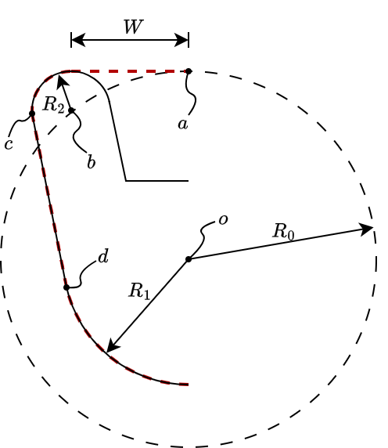
Tangency relationship between $c$ and $d$:
$$\frac{y_{c}-y_{b}}{x_{c}-x_{b}}=\frac{y_{d}}{x_{d}}$$

Positions of $c$ and $d$ expressed using the angle of tangency, $θ$:

$$x_{c}=x_{b}-R_{2}\cos\left(θ\right), y_{c}=y_{b}-R_{2}\sin\left(θ\right) \\ x_{d}=-R_{1}\cos\left(θ\right), y_{d}=-R_{1}\sin\left(θ\right)$$

Research Plan
- Single McKibben with radials on it to test lowest-hanging fruit
  - Lengths of radials
  - Widths of radials
  - Attachment point size & location
  - Pre-expansion

Some notes
PLA does not bond well to PET or to Nylon, two common mesh materials
x-center and z-offset:
- X=271mm
- Y > 50
- Z=33.5mm
Cura puts the origin at the center, so I’m looking for 271-150 = 121 as the x position for cura, z should be fine as-is. Luckily, it seems that cura puts object centers at the center of their bounding box, so that should make centering designs on the x-axis pretty easy.

Can add a ‘phantom block’ in cura that will stop the extruder from moving through that region, just need to make settings so that it won’t retract move over printed parts

“O” is 0 filament retraction before printing, 140% initial layer flow, 240C initial layer temp, 8 mm/s initial layer speed
“X” is 0 filament retraction before printing, 200% initial layer flow, 240C initial layer temp, 8 mm/s initial layer speed – this worked best

Relevant Prior Research
Three-Dimensional Printed Braided Sleeves for Manufacturing McKibben Artiﬁcial Muscles
- Contains references for the claim that McKibben muscles “exhibit very similar performances to skeletal muscles”
- Mentions that tensile force decreases with increasing braid angle
- Extrusion-printed PCL on a rotating steel mandrel
- Printing procedure:
  - Print first helix by sweeping the nozzle right to left while rotating the mandrel clockwise
  - Dip setup in water-soluble alginate, which prevents the printed strands from fusing at crossover points
  - Print second layer by sweeping the nozzle left to right while rotating the mandrel clockwise
  - Soak setup in water to remove the alginate
  - Print end connectors
  - Remove from mandrel
Third–Generation Pleated Pneumatic Artificial Muscles for Robotic Applications: Development and Comparison with McKibben Muscle
- An interesting pleated approach that avoids the interlaced fibers of a traditional McKibben muscle, thereby reducing frictional losses
- Expands more at its center than at its ends, while traditional McKibben muscles expand roughly uniformly along their length
- An airtight fabric (woven polyester cloth with a polymer liner) is woven/folded around strands of Kevlar chord (actually just one strand that makes many switchbacks)
Hacker makes 4th axis cylindrical rod printer

